SUPPORTING INFORMATION

Bridging Chemistry and Creativity: A Cyanotype Photography, Toning and UV Shielding for First-Year Undergraduate Students
Tannavi Badhan#, Rashika#, Sushmita*
Dept of Chemistry, Netaji Subhas University of Technology, Dwarka Sec- 3, Delhi-110078, India

S.No | Table of contents | Page
1 | General Information and Method | S2-S3
2 | Pre-lab student work | S3-S4
3 | Schematic Representation | S4-S5
4 | Copies of UV-Vis, FTIR, PXRD spectra | S5-S7
5 | Evaluation of Learning Outcomes: | S8

General Information and Method.
1) Purpose
The experiment is designed to provide a sustainable and green approach to synthesising Turnbull’s Blue. It is intended for undergraduate first-year chemistry students with fundamental laboratory skills and aims to enhance their proficiency in various aspects. This experiment helps first-year undergraduates to develop a deeper interest in coordination chemistry, and photochemical processes, i.e.. cyanotype formation and its effects of UV light, chemical composition, and exposure time.
- To introduce an interdisciplinary lab experiment by combining artistic creativity and chemical principles via cyanotype (Turnbull’s Blue) photography.
- To demonstrate the photochemical processes, i.e.. cyanotype formation, majorly on the effects of UV light, chemical composition, and exposure time.
- To explore the impact of toning agents (e.g., green tea, coffee, etc.) on color variation, contrast, and quality of prints.
- To investigate the use of sunscreen as UV-blocking materials, to control exposure and manipulate image outcomes.
- To promote hands-on learning of laboratory skills, including solution preparation, safe chemical handling, and techniques like UV–Vis, FT-IR, and PXRD.
- To highlight the educational and artistic significance of cyanotype photography for first-year undergraduate B.Tech students.
- Lastly, to illustrate applications, including evaluating sunscreen effectiveness and exploring green chemistry practices in photochemical experiment.
2) Materials and equipment
EXPERIMENTAL OVERVIEW
The solutions and apparatus form the basis for preparing light-sensitive materials and conducting the cyanotype photographic process.
APPARATUS REQUIRED:
The preparation and experimental setup involve the use of four 250 mL beakers and two 100 mL beakers, a 100 mL graduated measuring cylinder, acrylic Sheets, two 100 mL China dish or troughs for chemical processing and forceps.
CHEMICAL REQUIRED: Chemical reagents and their associated Molarity and Volume for experimental preparation as follow:

Table S1:

Chemical Name | Formula | Molar Mass (g/mol) | Molarity | Volume (ml)
Potassium oxalate | (COOK)₂.H₂O | 184.23 | 0.50 | 100
Potassium ferricyanide | K₃[Fe(CN)₆] | 329.25 | 0.10 | 200
Diammonium hydrogen orthophosphate | (NH₄)₂HPO₄ | 132.06 | 3.50 | 20
Ferric chloride (Anhydrous) | FeCl₃ | 162.20 | 0.67 | 100
Hydrochloric acid | HCl | 36.46 | 0.10 | 200
Procedure for Cyanotype Preparation: Cyanotype synthesis was carried out without the need for prior purification of reagents or solvents. This scientific content makes it an ideal exercise for first-year undergraduates as part of a Bachelor of Technology degree programs. The preparation of chemical solutions for the cyanotype process requires careful measurement of reagents according to their specified molarities and volumes. The following chemicals are prepared as solutions:
- Potassium Oxalate [(COOK)₂·H₂O]: A 0.50 M solution is prepared by dissolving 9.21 g (0.50 mol/L×184.23 g/mol) in deionized water and diluting to 100 mL.
- Potassium Ferricyanide (K₃[Fe(CN)₆]): Prepare a 0.10 M solution by dissolving 6.59 g (0.10 mol/L×329.25 g/mol) in deionized water and making up the volume to 200 mL.
- Diammonium Hydrogen Orthophosphate [(NH₄)₂HPO₄]: For a 3.50 M solution, weigh 9.24 g (3.50 mol/L×132.06 g/mol) and dissolve in deionized water to a total volume of 20 mL.
- Ferric Chloride (FeCl₃): A 0.67 M solution is prepared by dissolving 10.87 g (0.67 mol/L×162.20 g/mol) in deionized water and making up the volume to 100 mL.
- Hydrochloric Acid (HCl): Prepare a 0.10 M solution by diluting concentrated HCl to a final volume of 200 mL.

Student laboratory instruction
Experimental principle: Due to its excellent chemical selectivity, functional group tolerance, and mild reaction conditions, this reaction has become a very practical method in organic synthesis. This approach has garnered significant attention for utilising water instead of organic solvents and eliminating the by-product, which effectively enables students to bridge the gap between theoretical knowledge of green synthesis and its practical application.
This experiment provides a simple, efficient, cost-effective, and environmentally benign synthesis of Turnbull’s Blue and its real-world applications. The cyanotype process is a photochemical reaction where ferric ions (Fe³⁺) are reduced to ferrous ions (Fe²⁺) under UV light, which then react with ferricyanide ions to form Turnbull’s Blue (Fe₃[Fe(CN)₆]₂), producing the characteristic blue image. Because of its remarkable colour-changing behaviour under UV light, this protocol serves as an effective and engaging approach that connects chemistry with creativity. The experiment illustrates key concepts of photochemistry, redox reactions, and coordination chemistry. Moreover, this experiment links chemistry and creativity, which helps students understand light-induced reactions and their real-world applications.
General procedure for the synthesis of Turnbull’s Blue (potassium tris(oxalato)ferrate(III) trihydrate K₃[Fe(C₂O₄)₃]·3H₂O).
To prepare the coordination complex species, dissolve 9.21 g of potassium oxalate monohydrate in 100 mL of a 0.5 M solution within a 250 mL beaker. Then, 20 mL of diammonium hydrogen orthophosphate solution should be added while ensuring the process occurs under diffused light inside a cupboard to minimise photodegradation. Gradually introduce 100 mL of ferric chloride hexahydrate solution (10.86 g; 0.67 M) into the mixture, stirring continuously. Initially, green ferric oxalate precipitates form, which then dissolve upon agitation, yielding the desired species.
Pre-lab student work: Traditional organic synthesis relies on hazardous reagents and inefficient reaction processes. Green chemistry promotes sustainability by using renewable, eco-friendly methods to optimise atom economy, energy efficiency, and waste reduction via photochemical reaction.
- Students must be familiar with starting material and product structural features using ChemDraw.
- Students must be acquainted with photochemical reactions using green principles.
- Students must read the details of the background of the experiment and the procedure before coming to the lab
Students must review spectroscopic techniques like UV-Vis, FT-IR etc. Through this experiment, students learn how to record and analyse the spectra

Schematic representation
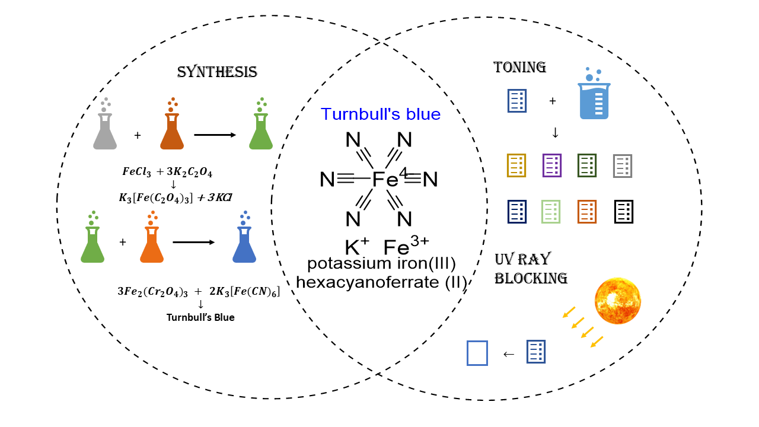

CHARACTERIZATIONS
A representative spectrum obtained by a student pair group to further verify the successful synthesis of Turnbull’s blue using the spectrum of UV-vis, FT-IR and PXRD spectra.
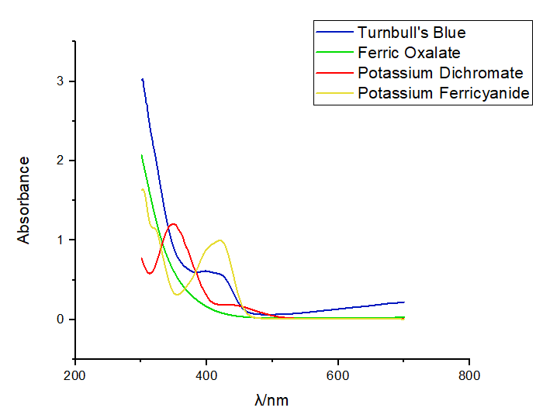
Graph-S1: UV Data: The absorption spectra of [Fe₂(C₂O₄)₃]³⁻ (green line), Fe₃​[Fe(CN)₆​]_{2​} (blue line), K₂Cr₂O₇ (red line), K₃[Fe(CN)₆] (yellow line) in a 0.1 mol L⁻¹ H₂SO₄ solution Turnbull’s Blue = ferrous ferricyanide

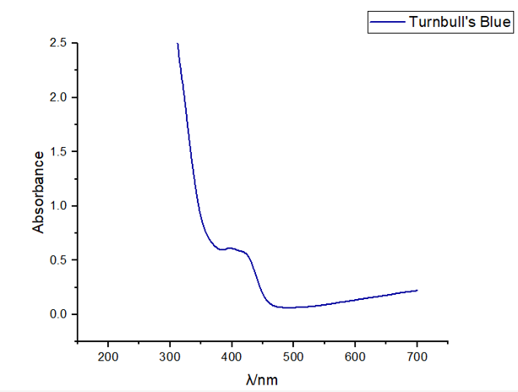
Graph-S2: UV–vis absorption spectrum of Turnbull’s Blue pigment
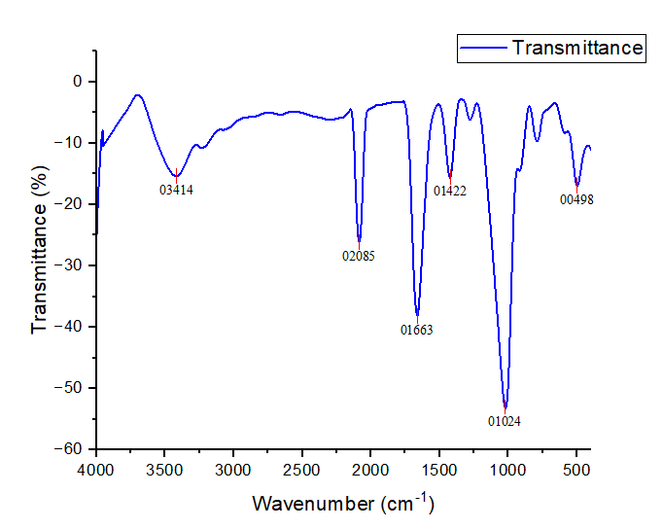
Graph-S3: FTIR spectrum of Turnbull’s Blue pigment
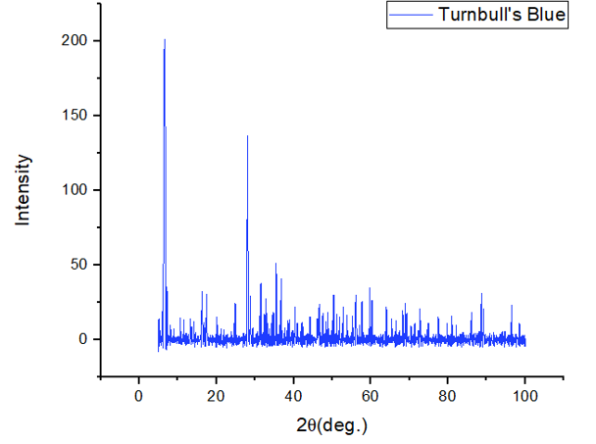
Graph-S4: PXRD pattern of Turnbull’s Blue pigment

Before conducting experiments, the instructor should consider the following aspects:
- The instructor must ensure that all required apparatus for the experiment is available in a clean and dry condition.
- Before experimenting, the instructor must check the working condition of the emergency laboratory's safety equipment, including emergency eye wash showers and fire extinguishers etc.
- The instructor should oversee students as they review experiments in advance, ensuring they have a fundamental understanding of the experimental and prior basic knowledge of the literature survey, and also emphasise “Safety and Hazards” to students before experimenting.
- The instructor should thoroughly explain the experimental procedures, guide students in carefully observing reaction phenomena and their real-world applications.
Evaluation:
Students' experiments are assessed based on five criteria: literature review report/ background work report (10 points), adherence to standardised experimental procedures (10 points), analysis of UV-Vis, IR data (10 points), real-world application of toning and sunscreen (10 points), and responses to post-experiment questions (10 points). The evaluation is categorized into five levels: excellent (50-41 points), good (40-31 points), medium (30-21 points), pass (20-11 points), and fail (<10 points).
- Excellent (50–41 points): Students demonstrate thorough preparation, independently follow standardised procedures, accurately analyse spectral data, effectively apply toning and sunscreen concepts to real-world contexts, and provide strong, well-reasoned responses to post-experimental questions.
- Good (40–31 points): Students demonstrate good preparation, competently perform the experiments, analyse spectral data with accuracy, apply toning and sunscreen concepts appropriately, and provide satisfactory responses to post-experimental questions.
- Medium (30–21 points): Students show adequate preparation, perform experiments with moderate understanding, analyse spectral data with some guidance, apply toning and sunscreen concepts with partial accuracy, and respond to most post-experimental questions.
- Pass (20–11 points): Students show limited preparation, perform experiments with help, provide incomplete or assisted analyses of spectral data, demonstrate minimal understanding of real-world applications, and respond to post-experimental questions inaccurately.
- Fail (<10 points): Students show little or no preparation, struggle to perform experiments independently, fail to analyse spectral data, and are unable to apply or discuss the experimental outcomes meaningfully.

Table S2: Evaluation Result

Level | Excellent | Good | Medium | Pass | Fail
No. of Students | 5 | 14 | 15 | 9 | 2

Evaluation of Learning Outcomes:
45 participating students answered the post-experiment assessment as part of their experiment. These analyses for the students are as follows:
- Literature Review and Background Work: Students were evaluated on their ability to conduct research and summarise the chemical basis of cyanotype photography, including photochemical reactions and coordination chemistry. A concise literature survey demonstrated their ability to link theoretical concepts to practical applications.
- Adherence to Experimental Protocols: Students’ performance in preparing sensitiser solutions, handling chemicals safely, and maintaining a systematic experimental workflow under photochemical conditions was assessed.

